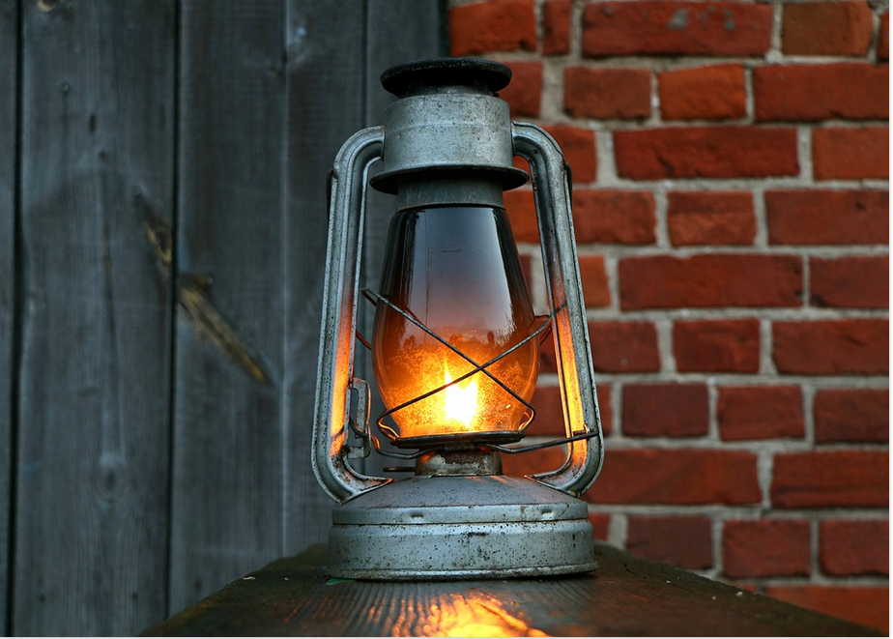

install LAMP stack
==============

Be Advised,
whenever you see the # symbol, this is a comment or a note which will be ignored by the computer system, and won’t be executed by the computer.

#install Web Server
sudo apt install -y apache2 apache2-utils

#install Database Server
sudo apt install -y mariadb-server

#make sure to install the following php extensions
sudo apt install sudo apt install -y php8.1 php8.1-imagick php8.1-mbstring php8.1-zip php8.1-xml php8.1-cli php8.1-cgi php8.1-
common php8.1-mysql libapache2-mod-php php8.1-fpm php8.1-gd

#restart Web & DB servers
sudo systemctl restart apache2
sudo systemctl restart mariadb

#run mysql_secure_installation cmd to secure db
sudo mysql_secure_installation

#create test php file to test php in Web Server
echo "<?php phpinfo(): ?>" | sudo mxwil /var/www/html/phpinfo.php

Thank you for viewing this document.

This document is licensed by the following::
Creative Commons License

